Easy access and quick transfers everyday

[Watch Video](https://www.kingston.com/en/video/play?videoId=MFFOgPvsTRJJV6GZ7XCIQUsE13ALZCZIRyj9-7_PsaZ_w-N-bnTXNxvzdaCCWUxGOIfqIheLxRufK1j1eSOAbg2&start=0&autoPlay=False&chromeless=False&captionOption=No)

DT Exodia

* [Intro](https://www.kingston.com/en/usb-flash-drives/datatraveler-exodia-usb-3-2-usb-flash-drive#product-features)
* [Specifications](https://www.kingston.com/en/usb-flash-drives/datatraveler-exodia-usb-3-2-usb-flash-drive#specifications)
* [Resources](https://www.kingston.com/en/usb-flash-drives/datatraveler-exodia-usb-3-2-usb-flash-drive#links)
* [Datasheet](https://www.kingston.com/datasheets/dtx_us.pdf)

[**Buy**](https://www.kingston.com/en/usb-flash-drives/datatraveler-exodia-usb-3-2-usb-flash-drive#atc)

DataTraveler Exodia USB Flash Drivewith Protective Cap and Keyring in Multiple Colors

Kingston’s DataTraveler® Exodia™ is a USB 3.2 Gen 1 compliant storage solution for laptops, desktop PCs, monitors and other digital devices. DT Exodia allows quick transfers and convenient storage of documents, music, videos and more. Its practical design and fashionable colors make it ideal for everyday use at work, home, school or wherever you need to take your data. DT Exodia is available in capacities up to 256GB1 and is backed by a five-year warranty, free technical support and legendary Kingston® reliability.

* Large loop easily attaches to key rings
* Practical cap protects the USB plug
* Multiple color options by capacity

Key Features



Ultimate portability

Range of capacities with colorful loop that easily attaches to key rings

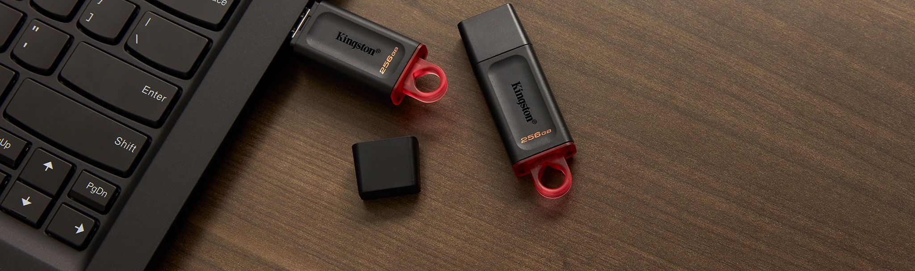

Quick and convenient

The lightweight USB 3.2 Gen 1 compliant storage solution that’s easy to take with you.

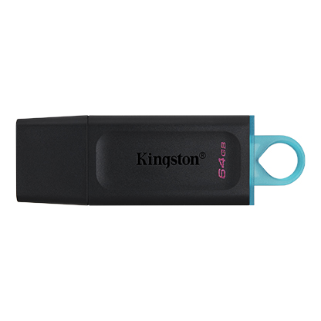

* [DataTraveler Exodia 64GB](javascript:void(0))
* [DataTraveler Exodia 64GB](javascript:void(0))
* [DataTraveler Exodia 64GB](javascript:void(0))

Capacity

 64GB

 128GB

 256GB

Packaging

 Single Pack

 2 pack

* Part Number: DTX/64GB
* USB 3.2 Gen 1 compliant
* 5-year warranty

[**Where to Buy**](https://www.kingston.com/en/wheretobuy)

Specifications

|  |  |
| --- | --- |
| Capacities1 | 64GB, 128GB, 256GB |
| Speed2 | USB 3.2 Gen 1 compliant |
| Dimensions | 67.3mm x 21.04mm x 10.14mm |
| Weight | 11g |
| Operating temperature | 0°C~60°C |
| Storage temperature | -20°C~85°C |
| Warranty | 5-year warranty with free technical support |
| Compatible with | Windows® 11, 10, macOS (v. 10.15.x +) , Linux (v. 4.4 +), Chrome™ OS |